**Stakeholder Analysis**

**Renovation & modernization of Auditorium**

**A&A construction LLC**

**OCT 2016**

STAKEHOLDER ANALYSIS

STAKEHOLDER

A stakeholder is any person, organization, social group, or society at large that has a stake in the business. Thus, stakeholders can be internal or external to the business. A stake is a vital interest in the business or its activities. It can include ownership and property interests, legal interests and obligations, and moral rights.

Stakeholders can:

• Affect a business

• Be affected by a business

• Be both affected by a business and affect a business

The concept of a stakeholder does have moral and ethical implications for business governance. If a business only has a duty to its shareholders, then the business may have no moral obligations to any other person, organization or society. On the other hand, if a business has a duty to its stakeholders, then a business must take into account the interests of its stakeholders as well and not focus completely on maximizing the interests of its owners.

Benefits of a stakeholder are:

• Opinions of stakeholder can improve the quality of your project.

• Gaining support from powerful stakeholders can help you to win more resources.

• By communicating with stakeholders can ensure that they fully understand what you are doing and understand the benefits of your project.

LIST OF STAKEHOLDERS AND ROLES

|  |  |
| --- | --- |
| ROLE | NAME |
| Project Sponsor | Bill Clinton |
| Project Review Group | Donald Trump |
| Project Manager | Hillary Clinton |
| Quality Manager | Mike Cobb |
| Procurement Manager | Rajesh Chhetry |
| Communications Manager | Aditya Adibhatta |
| Project Office Manager | Aravind Kumpatla |
| Civil Engineer | Thomas jefferson |
| Architectural Technician | Peterson |
| CAD or computer-aided design and drafting (CADD) Operator | Mark |
| Construction Technician | Jon Doe |
| Roofing Technician | Manaswi |
| Public |  |
| Sound technician | Layman |
| I.T. technician | Steve |

**Power/interest Grid with stakeholders marked**

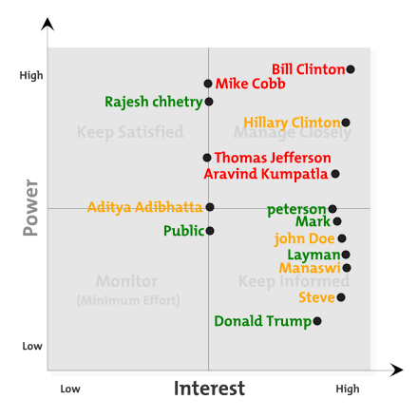

**Stakeholder Analysis Matrix**

|  |  |  |  |  |  |  |
| --- | --- | --- | --- | --- | --- | --- |
| **Name** | **Role** | **Interest** | **Influence** | **Unique Facts** | **Expectations** | **Ways to manage expectations** |
| **Bill Clinton** | **Project sponsor** | **High** | **High** | **Very demanding and wants to know all details** | **Must be done within budget and time he proposed** | **Frequent updates and engage in important decisions** |
| **Donald Trump** | **Review Group** | **High** | **Medium** | **Interested in facts** | **Everything must be done according to plan** | **Frequently updating changes regularly** |
| **Hillary Clinton** | **Project Manager** | **High** | **High** | **Interested in all the details** | **Everything has to be done according to plan** | **Engaging in all important decision making aspects** |
| **Mike Cobb** | **Quality Manager** | **Medium** | **High** | **Particular about things to be done as per planning** | **Particular about things to be done as per planning** | **Participation in brainstorming activities** |
| **Rajesh chhetry** | **Procurement Manager** | **Medium** | **High** | **Particular about things to be done as per planning** | **Particular about things to be done as per planning** | **Explain about how things work in real time** |
| **Aditya Adibhatta** | **Communication Manager** | **Medium** | **Medium** | **Friendly with everyone** | **Expect the same from others** | **Explaining the facts about real time scenarios compared to assumptions** |
| **Aravind Kumpatla** | **Project office manager** | **High** | **Medium** | **Things to run as per the book** | **Expect the same from others** | **Learning from real time facts** |
| **Thomas Jefferson** | **Civil Engineer** | **Medium** | **Medium** | **Hard working** | **Expect the same from others** | **Can be managed by detailing the things on ground** |
| **Peterson** | **Architectural Technician** | **Medium** | **medium** | **Doesn’t make much noise** | **Things will be better** | **Participating in regular activities** |
| **Mark** | **CAD operator** | **Medium** | **High** | **Creative** | **More useful in difficult situations** | **Engaging in decisions which involves in structural changes** |
| **John Doe** | **Construction Technician** | **Low** | **High** | **Not bound to timelines** | **Things will be better** | **Make him to bound to timelines** |
| **Manaswi** | **Roofing Technician** | **Low** | **High** | **Hardworking and funny** | **Can be more creative** | **Including in all creative things** |
| **Layman** | **Sound Technician** | **Low** | **High** | **Creative** | **Try to do things out of scope** | **Explaining how to work in real time** |
| **Steve** | **I.T. Technician** | **Low** | **high** | **Driving many initiatives right now** | **Won’t be disturbed too much** | **Frequent updates and engage in important decisions.** |